**Synopsis**

On

**An In-depth Analysis of FDA 483 Warning Letters for Medical Devices and Drugs: Case Studies, Statistical Trends, and Recommendations for Improved Regulatory Compliance**

for

**M Pharmacy**

by

**Shikha Sharma**

Registration No: 2250981209

**Chitkara College of Pharmacy**,

**Chitkara University, Punjab, India**



**Under the supervision**

**of**

**Dr. Chander Parkash Dr. Thakur Gurjeet Singh**

**Associate Professor Professor & Dean**

**Chitkara College of Pharmacy, Chitkara College of Pharmacy**

**Chitkara University, Punjab Chitkara University, Punjab**

**1.** **Introduction**

**1.1 United States Food and Drug Administration**

The United States Food and Drug Administration (USFDA) is an agency within the U.S. Department of Health and Human Services that is responsible for protecting public health by ensuring the safety, efficacy, and security of human and veterinary drugs, biological products, medical devices, human tissues, and cosmetics. It also oversees food safety and nutrition, and regulates the tobacco industry.

The USFDA was established in **1930** under the **Food, Drug, and Cosmetic Act (FD&C Act). The FD&C Act .**This act was passed in response to a number of public health scandals, including the death of over 100 people from the consumption of arsenic-contaminated elixir. The FD&C Act gave the USFDA the authority to regulate the safety and efficacy of food, drugs, and cosmetics.

The USFDA has **223 field offices**, **13 laboratories, 9 Centers and 13 Headquarters** located throughout the 50 states, the United States Virgin Islands, and Puerto Rico.

USFDA plays a vital role in protecting public health. The agency has developed and implemented a wide range of regulations to ensure the safety of FDA-regulated products. It also conducts inspections of manufacturing facilities and clinical research sites to ensure that companies are complying with FDA regulations.

1.1.1 **Roles and Responsibilities of USFDA**

The United States Food and Drug Administration (USFDA) has a wide range of roles and responsibilities, the major ones are as follows**:-**

1. **Protecting Public Health:**The USFDA's primary responsibility is to protect public health by ensuring the safety, efficacy, and security of FDA-regulated products. This includes food, drugs, medical devices, human tissues, and cosmetics.
2. **Overseeing Food Safety and Nutrition:**It oversees the safety of the US food supply This is done by developing and enforcing food safety regulations, inspecting food processing facilities, and educating consumers about food safety and nutrition.
3. **Regulating the Tobacco Industry:**The USFDA regulates the manufacture, marketing, and sale of tobacco products. This includes setting standards for tobacco products, restricting advertising and marketing, and educating consumers about the risks of tobacco use.
4. **Approving New Products:**The agency reviews and approves new drugs, biological products, medical devices, and food additives before they can be marketed in the United States. This process is designed to ensure that these products are safe and effective for their intended use.
5. **Post Marketing Surveillance:**The agency monitors FDA-regulated products after they are marketed to ensure that they continue to be safe and effective. This includes conducting inspections, investigating adverse events, and reviewing new scientific data.

**1.2 USFDA Form 483 : Notice of Inspectional Observation**

The FDA Form 483, officially known as **Notice of Inspectional Observations** and commonly referred to as “**483**,” is issued at the end of an on-site inspection of regulated facilities by the FDA field investigator at the end of an inspection. 483s under Section 704(b) of the FD&C Act .

Inspections are carried out at manufacturing sites for Quality, Safety, Efficacy assessment of drugs, biologicals or Medical Devices(class II, III)

They can be written on paper, filled and submitted electronically, or created in a PDF and printed

**1.2.1 When is it Issued?**

After the complete audit of company’s facility, equipment, processes, controls, products, employee practices, or records by USFDA investigator shows violations of the Food Drug and Cosmetic (FD&C) Act and related Acts.

**1.2.2 How is it Issued?**

It is typically given to the inspected facility's management at the conclusion of the inspection, during a closing meeting that occurs on-site at the facility being inspected. It is handed out directly to the facility's representatives by the FDA inspector(s) or investigator(s) who conducted the inspection**.**

**1.2.3 How to access FDA 483 issued to a Company?**

1. **Freedom of Information Act (FOIA) Request:**

* It can be requested by anyone but consumes time and money.
* FDA has to redact confidential information(TS) from the report hence ,the FDA charges $46 per hour for FOIA requests.
* if the 483 has not been previously requested, it make take up to $100 and almost 2 years.

1. **FDA Establishment Registration Database:**

* The FDA maintains a database of registered companies and their inspection reports.
* Through this database one can identify which companies have received Form 483s.
* Proceed with a FOIA request to obtain the specific documents.

**1.3Most Common implications of FDA 483**

1. **Implications for Medical Devices**

|  |  |
| --- | --- |
| **Code of Federal Regulations (CFR)** | **CFR Title** |
| **21 CFR part 811** | Medical Device Reporting |
| **21CFR part 820** | Quality System Regulation for Medical Devices. |
| **21 CFR part 803.7** | Definitions in Medical device reporting |
| **21 CFR part 801** | Labeling |
| **21 CFR part 807** | Establishment Registration and Device Listing for Manufacturers and Initial Importers of Devices. |

1. **Implications for Drugs**

|  |  |
| --- | --- |
| **Code of Federal Regulations (CFR)** | **CFR Title** |
| **21 CFR Part 211** | Current Good Manufacturing Practice (cGMP) for Finished Pharmaceuticals |
| **21 CFR Part 211 ,Subpart F** | Production and Process Control |
| **21 CFR Part 211 ,Subpart J** | Records and Reports: |
| **21 CFR Part 314 ,Subpart I** | Discontinuation of Post marketing Studies |
| **21 CFR Part 314 , Subpart L** | Reporting of Adverse Experiences |

**1.4 Overview of Final Day of Inspection**

1. On the last day of the inspection, the lead inspector meets the manufacturer to discuss findings, provide feedback and issue FDA 483 (**exit interview/ closeout meeting**)
2. Manufacturer should **make corrections**, ask questions and discuss next steps.
3. Lead inspector prepares and submits a **written report** to FDA HQ for evaluation.
4. Final report, i.e. **EIR(Establishment Inspection Report)** is available after 3-6 months of inspection also available via FOI (Freedom of Information).
5. Manufacturing facility has to submit a detailed **response to FDA district office** within 15 business days of issuance of FDA 483 .
6. Inspectors, Subject Matter Experts, Compliance officers and if needed a special committee evaluate the response and **CAPA**.
7. **Follow up inspection** may be done in case of high risk facilities or doubt for checking CAPA , QRM, QMS and suggestions implementation.
8. **Closure of Inspection** –FDA formally closes out the inspection once it is satisfied with the responses and implementation.

**1.5 Statistical Overview and Trends of USFDA Form 483**

**1.5.1 Methods used to collect statistical data**

The USFDA collects statistical data on 483 observations from a variety of sources like**:-**

1. **Inspection Reports**: When an FDA inspector observes a violation of FDA regulations during an inspection, they issue a 483 observation to the company. The 483 observation lists the specific violation that the inspector observed.
2. **Company Responses to 483 observations:**Companies are required to respond to 483 observations within 15 business days. In their response, the company must describe the corrective actions that they will take to address the violation.
3. **Warning Letters**: The USFDA issues warning letters to companies that are in violation of FDA regulations. Warning letters often describe 483 observations that were cited during a recent inspection.
4. **Establishment Inspection Reports (EIRs):** EIRs are comprehensive reports that document the findings of FDA inspections. EIRs may include information on 483 observations, as well as other findings, such as observations that were not cited on Form FDA 483.

**1.5.2** **Methods used to Analyse Statistical Data**

The USFDA Analyses statistical data on 483 Observations using:-

1. **Descriptive Statistics**: Used to summarize data. For example, the USFDA may use descriptive statistics to calculate the mean, median, and mode of the number of 483 observations issued each year.
2. **Inferential Statistics**: Used to draw conclusions about the population based on a sample. For example, the USFDA may use inferential statistics to test the hypothesis that the number of 483 observations issued for drugs is different than the number of 483 observations issued for medical devices.
3. **Data Visualization**: Used to create charts and graphs that help to identify trends and patterns in the data. For example, the USFDA may use data visualization tools to create a bar chart showing the most common 483 observations for drugs and medical devices, or a line chart showing the trend in the number of warning letters issued over time.
4. **Text Analysis**: Used to extract information from unstructured text data. For example, the USFDA may use text analysis tools to identify the root causes of compliance problems described in 483 observations or warning letters.

1. **Machine Learning**: Used to develop predictive models that can be used to identify companies that are more likely to receive a 483 observation or warning letter. These models can be used to prioritize inspections and to provide targeted guidance to companies.

**1.5.3** **Statistical Overview from USFDA FisCal Year Reports**

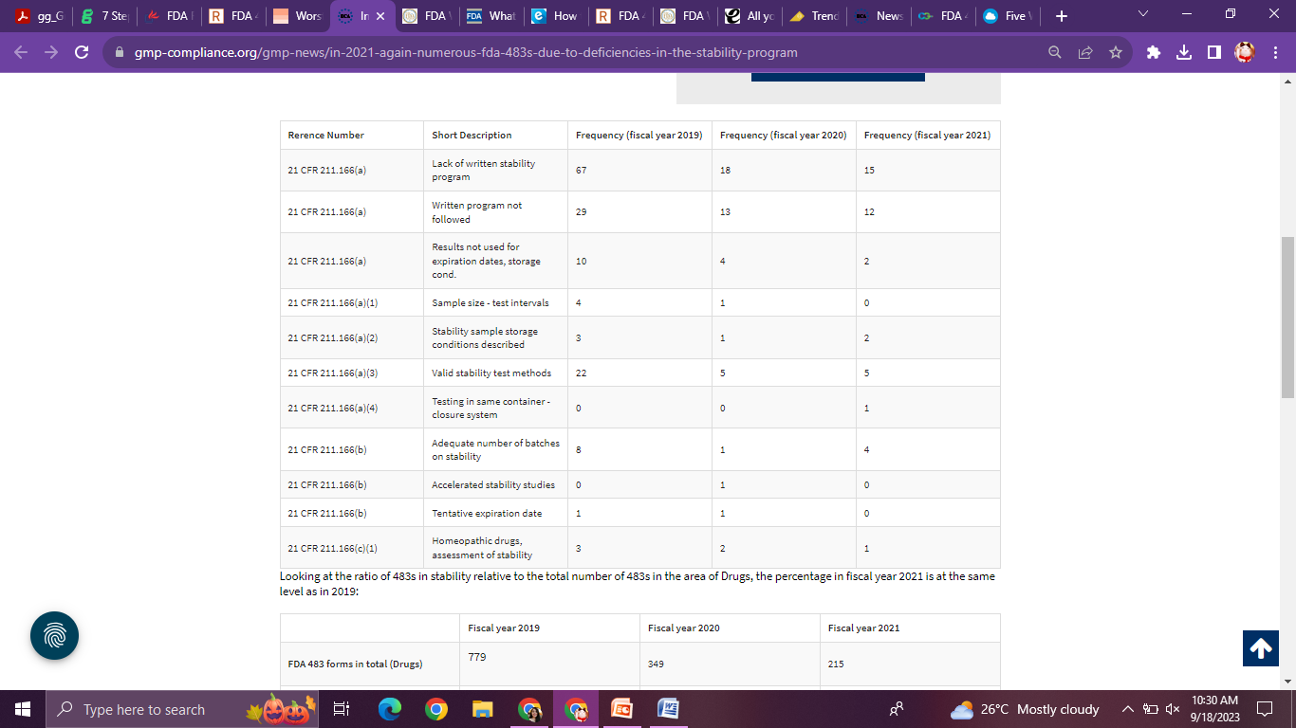

**Fig1**. **FDA 483s due to Deficiencies in the Stability Program**

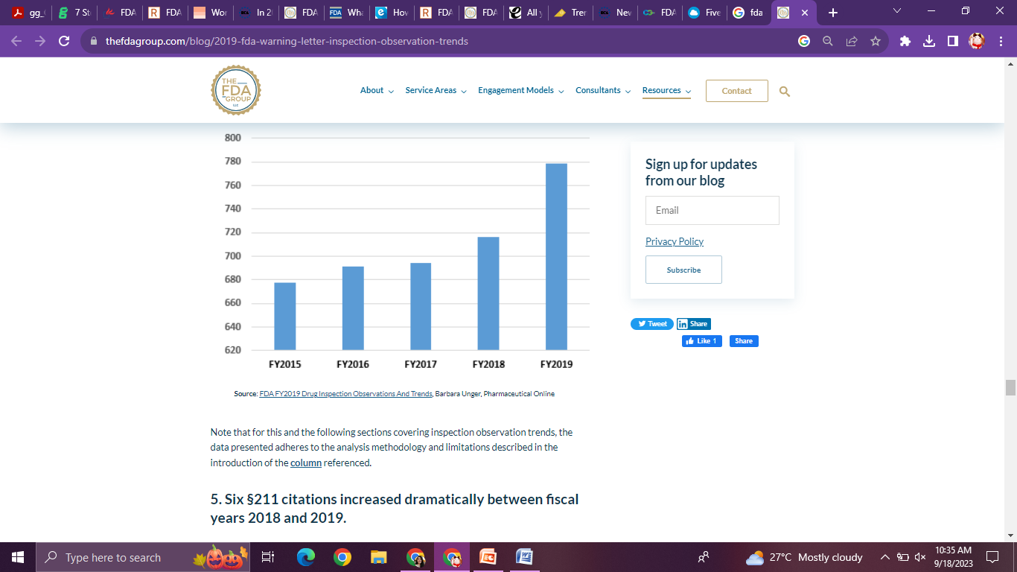

**Fig2.The 483 trends from the fiscal year 2018-2022**

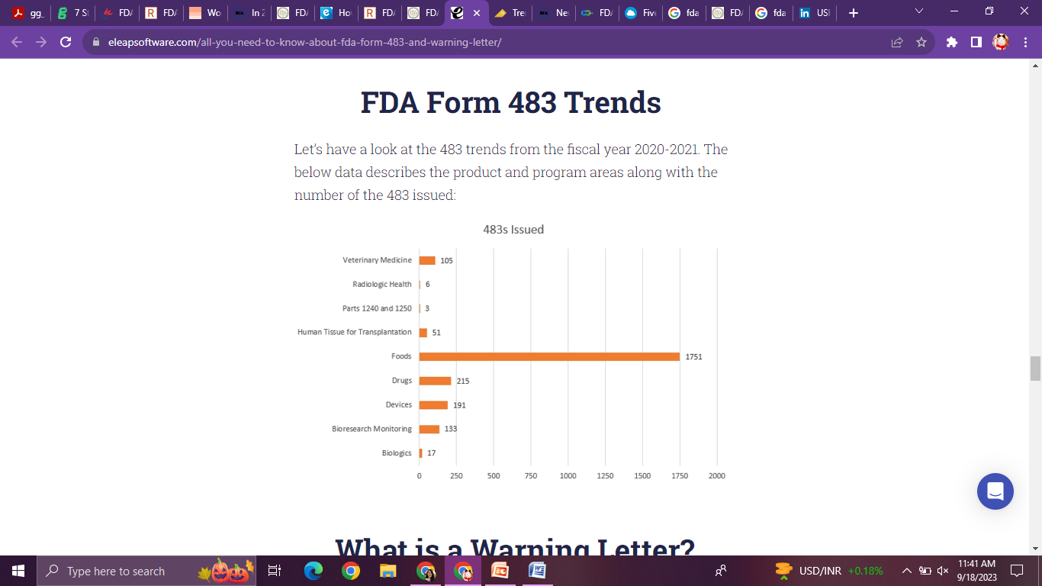

**Fig3.The product and program areas along with the number of the 483 issued in these years.**

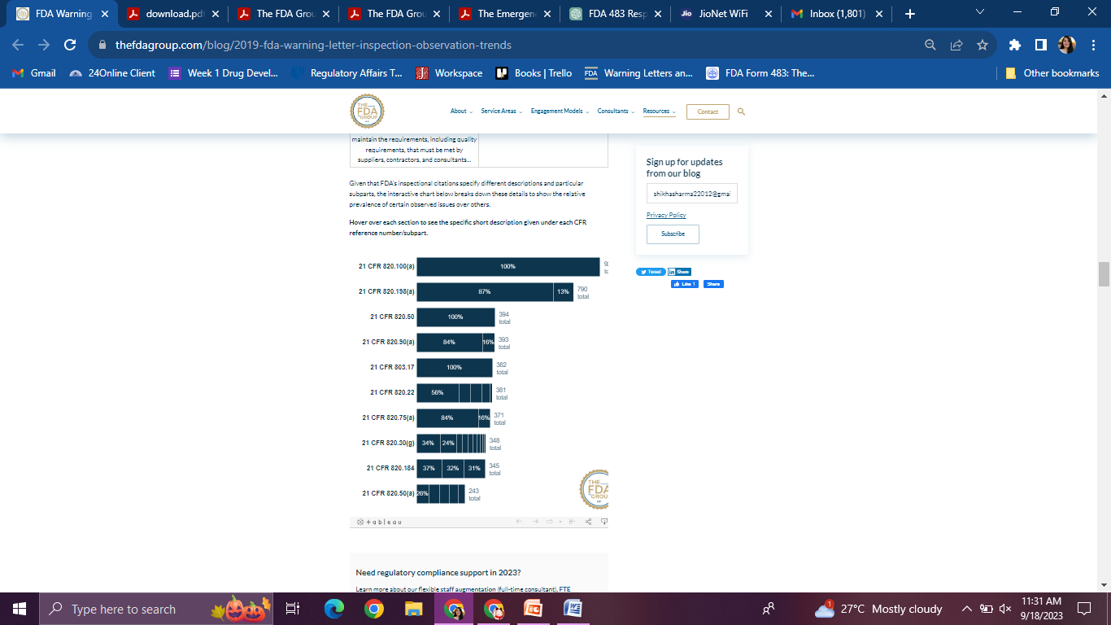

**Fig4.USFDA Inspection Citations for Medical Devices from FY2018-FY2022**

**1.5.4 What If, FDA 483 Response is Inadequate or Inappropriate?**

Unsatisfactory FDA 483 Response letter serves as a precursor to the issuance of a Warning Letter by the U.S. Food and Drug Administration (FDA).

* 1. **USFDA Warning Letters**

A Warning Letter, as per the U.S. FDA's definition, is an official correspondence issued by the FDA to a company or individual involved in regulated industries (such as pharmaceuticals, medical devices, food, or cosmetics) to communicate significant violations of regulations or laws. These violations pertain to non-compliance with Current Good Manufacturing Practices (cGMP), labeling requirements, adulteration, misbranding, and other regulatory standards. Warning Letters serve as formal notification of these violations and outline the corrective actions required to achieve compliance.

**1.6.1Types of USFDA Warning Letters**

1. **General FDA Warning Letters**When FDA finds that a manufacturer has significantly violated FDA regulations, FDA notifies the manufacturer in the form of a Warning Leter.The Warning Letter identifies the violation, such as poor manufacturing practices, problems with claims for what a product can do, or incorrect directions for use. It makes clear that the company must conduct CAPA within given time frame.

**2. Tobacco Retail Warning Letters**Compliance check inspections of tobacco retailers occur periodically to determine a retail establishment’s compliance with Federal Food, Drug, and Cosmetic Act, as amended by the Family Smoking Prevention and Tobacco Control Act (Tobacco Control Act) and its regulations in effect, such as ;the Regulations Restricting the Sale and Distribution of Cigarettes and Smokeless Tobacco to Protect Children and Adolescents, found at Title 21 ofthe Code of Federal Regulations, Part 1140 **(21 C.F.R. Part 1140).**

**3. Drug Marketing and Advertising Warning Letters**These are sorted by month and only cover Division of Drug Marketing and Communications and Drug Warning Letters.Cyber" letters are sent electronically via the Internet to web sites that offer to sell online prescription drugs that may be illegal. The letters warn these web site operators that they may be engaged in illegal activities and informs them of the laws that govern prescription drug sales.

**4.Warning Letter Close-Out Letter Program**A close-out letter may issue when, based on FDA’s evaluation, the firm has taken corrective action to address the violations contained in the Warning Letter. This procedure applies to Warning Letters issued on or after September 1, 2009.

**1.6.2 Key Steps to Interpret FDA 483 and Warning Letters**

To evaluate the seriousness of FDA 483 other than VAI or OAI the following should be checked :-

**1. Is the 483/WL longer than 8-10 pages?**

FDA believes, if one Quality System is out of control, they are all out of control.

Systemic Non compliance- patient safety issues

**2. Are there detailed examples for any observations?**

An observation supported by more than 3 examples is where FDA is trying to give a message.

E.g. China 6.5 pages example- record manipulation.

**3. Are there observations indicating a recurrence of issues from prior inspections?**

Company’s response was acceptable previously but CAPA not implemented, hence, quality is compromised.

May lead to additional stringent action for non compliance and violation.

**3. Are there observations indicating a recurrence of issues from prior inspections?**

Company’s response was acceptable previously but CAPA not implemented, hence, quality is compromised.

May lead to additional stringent action for non compliance and violation.

**5. Does the observation include lack of data integrity, aseptic practices with risk of cross contamination?**

In past 5 years, most of the FDA483 have been followed by warning letters or additional enforcement action due to these issues.

**6. How many inspectors visited the facility and who were they?**

Presence of a national expert in the committee  **-** indicated FDA’s focus on the product/facility.

Facility may be high risk or previously unresolved violations, likely to increase seriousness of the inspection.

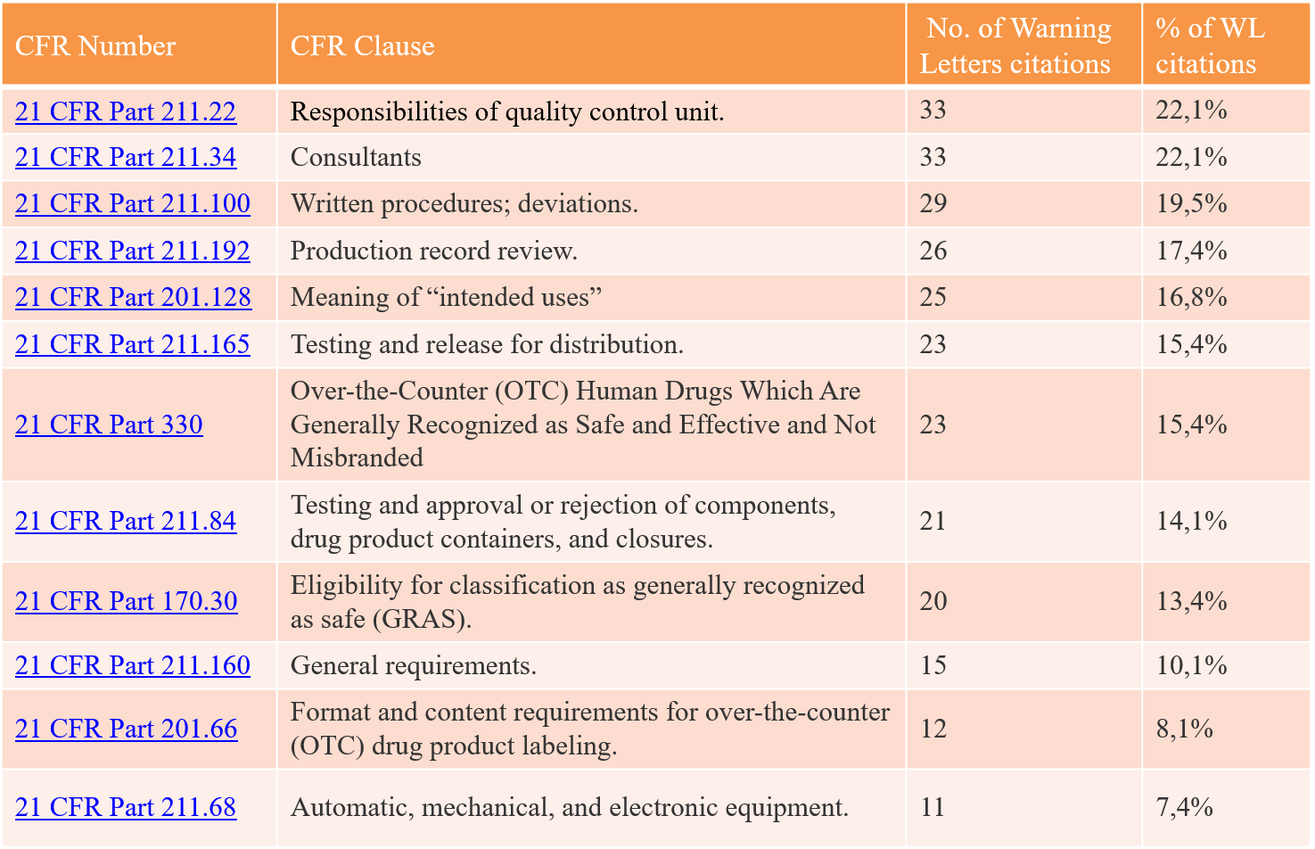

**Fig 5.Top 10 Reasons for Warning Letters**

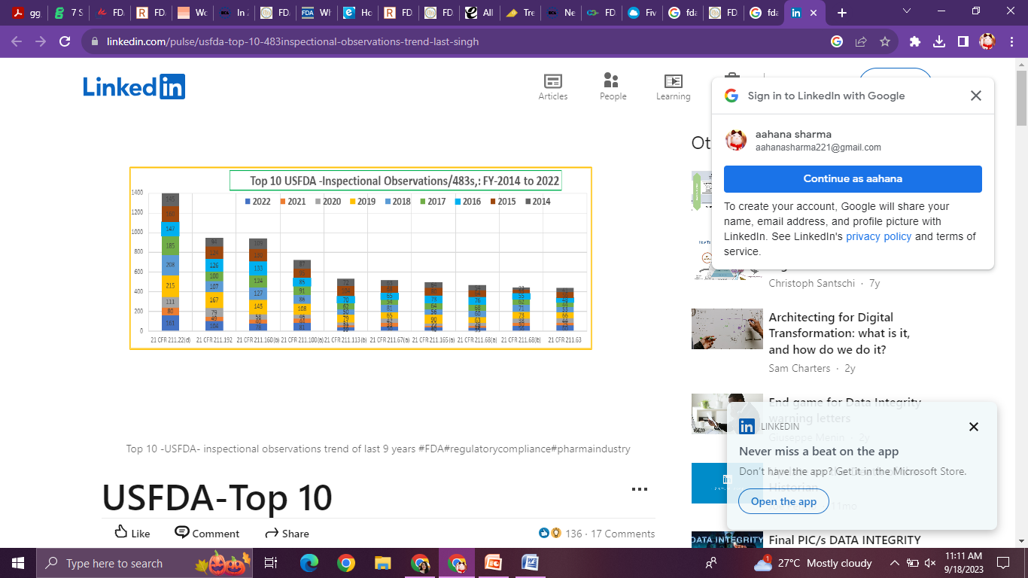 **Fig6**.**Top 10 FDA 483 Citations from Fiscal Year 2014-2023**

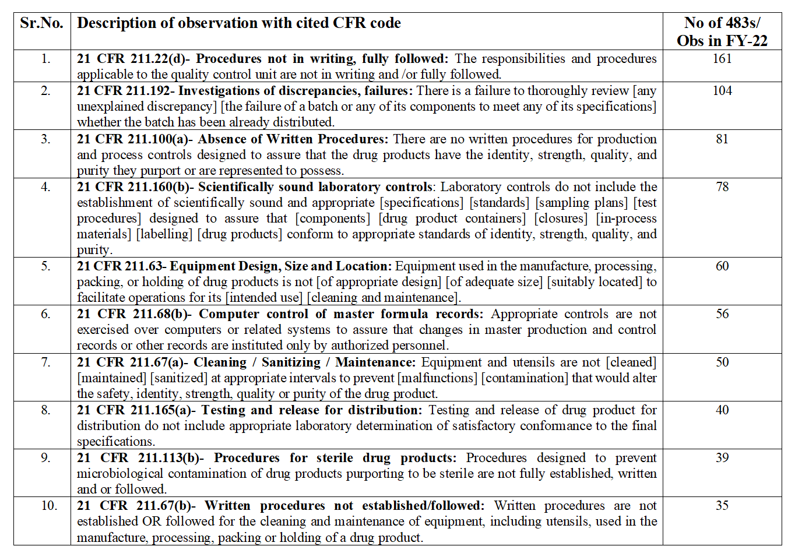

**Fig7.FDA 483 Observations from FisCal year 2022**

**1.7 Responding to FDA 483 and Warning Letters**

Responding to an FDA Form 483 is a critical regulatory obligation for pharmaceutical, biotechnology, and medical device facilities. This process involves addressing observed non-compliance issues meticulously, showcasing a steadfast commitment to regulatory adherence, and upholding stringent standards of quality and safety.The approaches can be broadly categorized into 3 categories :-

1. **PRE RESPONSE**

* **Direct Communication :** With inspector for clarification
* **Disagreement is Possible:** Challenge observations if they don’t align.
* **Back Claims with Evidence:** Provide evidence such as data, references, or code references.
* **Avoid excuses :** Only data driven justifications

1. **OFFICIAL RESPONSE**

* **Systemic and Global Approach:** Address observations broadly and across all company sites to prevent recurring issues.
* **Well-Reasoned:** Identify root causes, provide specific explanations. Back the response with revised SOPs and protocols.
* **Timely Submission : 15 days**
* **Leadership Commitment:** Include a commitment or statement from senior leadership in your response.

1. **POST RESPONSE**

* **Diligent Execution :**Of plan outlined in response
* **Communication is Key:** If unanticipated delays occur in remediation, communicate these delays promptly to the FDA.
* **Maintain Commitment:** the FDA sees response as a commitment. It essential to fulfill them as stated in your response.

**1.7.1The Roadmap to Response**

1. **Establish a Timeline and Plan of Action for Response Activities**
2. Setup a Response team, delegate tasks to meet the 15 day deadline.
3. Analyze what the FDA reviewers are expecting in response.
4. Define a list of actions that would support the response claims . Some common things to do would be (case by case basis) :-

* Evaluate the product impact (i.e., the impact an issue has to product)
* Remove the product from the market
* Place the product in inventory on hold
* Provide the procedure to the appropriate personnel
* Conduct training and provide evidence
* Consider hiring a third party expert or consultant for compliance remediation

**2.Identify Root Cause**

* **Analysis and Data Examination :** Conduct a comprehensive analysis of the observation to understand its underlying causes. Review relevant data, records, and documentation related to the issue.
* **Use Tools:** Utilize problem-solving tools such as Fishbone Diagrams (Ishikawa), 5 Whys, or Failure Mode and Effects Analysis (FMEA) to systematically identify root causes.

**3.Issuing CAPAs**

* Once the root causes for each 483 observation are identified, draft and issue for corrective action plans, or CAPAs.
* A separate CAPA for each individual 483 is recommended.
* Your CAPAs should specify:

1. Description of the issue.
2. Copy and paste the exact wording of the FDA 483 observation
3. Root cause analysis
4. Immediate corrections required
5. action plan to prevent occurrence / recurrence
6. Assignment of CAPA owner

**4.Establish a Timeline**

* **FDA Expectations :** FDA expects address and mitigation to be carried out in stipulated time. Hence, establishing a timeline and delegating tasks is important.
* **Sense of Urgency:** While addressing 483 observations with urgency is important, avoid knee-jerk reactions. Set realistic timelines that align with your CAPA process.
* **Priority Management:** Time is crucial and CAPAs are a top priority, but a balance should be maintained between urgency and thoroughness to ensure effective resolution.
* **Communicate Doubts and Delays :** If, appropriate response actions take time or there are delays in submitting the response to the divisional office, communicate the same to USFDA
* **Realistic Commitment:** Make a commitment to timely resolution, but be realistic about the time required for corrective and preventive actions to be effective and sustainable.

**5. Draft a Structured Response Letter**

* Provide information to FDA in a manner that is easy to understand and navigate.
* Guide the reviewer. using Cover letter Body of the response, List of attachments and Table of accomplishments
* **Cover Letter**
* Determine the primary point of contact and signing your response letter.
* Address and define the reason for the letter, and define any terms used later in the letter.
* Discuss the commitment of to resolving the issues identified by the FDA 483s.
* Address any issues that relate to management responsibilities.
* Request a meeting with FDA if observations show systemic deficiencies or product health risk issues.
* Identify any points of disagreement.
* Introduce the appendices, and make a commitment for the next update response(Optional).
* Bullet list of what you have already accomplished– (Optional).
* Bullet list of the focuses in the upcoming month.
* Designate the cover letter and response confidential and not subject to Freedom of Information Act (FOIA) disclosure.
* Define the planned response timeline (i.e. once per month or every 6 weeks) and Close with contact details.

1. **Body of the Response: Appendix 1**

Appendix 1 should be titled descriptively, for example:

**E.g. “Appendix 1-09.10.2023, Response to 08.20.2023 FDA 483/Warning Letter” Ref no.2311**

* The beginning paragraph should explain that the firm is providing the completed and planned actions undertaken in response to FDA 483/ Warning letter.
* an explanation of the layout of the FDA observations and the company’s responses. It should also introduce the other appendices and explain what information they will contain.
* In the text of Appendix 1, list each FDA 483 observation word for word before the response. First respond to the general statement, and then to specific example.
* provide as attachments the evidence to support the response.
* The response to the observation should then continue to the part of the observation in which the investigator provided a specific example. (important)
* In the “Completed” and “Planned” sections, enter the actions or commitments. If there are no “completed” actions, then delete that row of the table. Similarly, if there are no “planned” actions, then delete that row of the table.
* Avoid being repetitious in your response, and instead should simply reference the reader to the prior response where the relevant actions (either completed or planned) are discussed.
* The observations should be ranked in order of significance (from most extreme to least extreme).
* The response to the observation should then continue to the part of the observation in which the investigator provided a specific example. (important)
* Use the “Response” section in a flexible way. It can be left blank, used to reference the reader to Appendix 3 or another section of the response, or used to explain supporting facts that may attenuate the FDA 483 observation.
* Check for Final confirmation as mentioned in the checklist.
* Finally, you should confirm that the response contains the following elements:–
* Systemic Correction(s) to the underlying problem(s).
* Corrective Action(s) for the specific example(s).
* Steps taken to identify, examine and correct of any other examples of the same type of problem not specifically found by FDA.
* Any actions taken that impact product which has been manufactured.
* If there is no impact, describe how this was determined.
* Any interim corrections or measures taken to assure compliance until permanent corrections can be effected.
* Timelines for the corrections. Be realistic and establish a schedule that shows urgency.
* Attachments (documents or records) that demonstrate that any action taken or reported as accomplished was actually implemented.
* This may include copies of updated procedures, copies of data collected, reports or summary reports, etc.
* The volume of documentation should be selected so as to provide the minimum information necessary to prove to FDA that the action was implemented, while also providing to FDA what FDA will expect to see.

1. **Appendix 2 : List of Attachments**

* Use a table format containing the number of the attachment and its title or description.
* Provide evidence that the FDA reviewer expects to see. This evidence includes procedures, training records, protocols, reports, memoranda etc.
* For E.g. The person assigned to collate the response should confirm that the attachment number in this list agrees with the number in “Appendix 1 - Body of the Response”; the title/description in the table matches the actual attachment that will be issued in the response; and the number of pages is entered into the table.

1. **Appendix 3 – Table Of Actions/Accomplishments**

* For Appendix 3 – Table of Actions/Accomplishments, use a table containing the number of each FDA 483 observation (or warning letter observation) and a brief description of the completed and planned actions.
* Provide FDA with updated responses each month/quarter this appendix should contain the entirety of actions accomplished.
* Make a List of Actions.” An example of a Table of Actions/Accomplishments follows. In the planned actions, state the date and then the action, “By <Month day, year> training will be performed” or “By <Month day, year> CAPA will close.
* If possible, assign subject matter experts to complete this table for the items assigned to them.
* The timeline for Responding to both FDA 483 and Warnigng Letters is 15 days.
* The time for implementation and responding with CAPA may vary as per complexity and seriousness of the issue.

**2. AIM AND OBJECTIVE OF THE STUDY**

**2.1 AIM**

To analyze USFDA Form 483 and Warning Letters issued to medical device and drug manufacturers, using case studies, statistical trends, and recommendations for preparing a compliance remediation guide and suggesting methods to improve regulatory compliance.

**2.2** **OBJECTIVES**

1. **To identify the most common reasons for 483 Observations and Warning Letters**   
   This will provide insights into the most common compliance problems. This information can be used by companies to develop more effective compliance programs and to identify areas where they need to improve their internal processes.
2. **To conduct case studies to understand root causes and develop recommendations**

This will provide insights into root cause of the compliance problems. This will help in preparing CAPA , improving Quality Risk management and Quality Management Systems.

1. **To evaluate existing regulatory compliance programs and develop recommendations for improvements**

* **MOTIVATION OF RESEARCH**
* **Regulatory Significance:** The FDA plays a pivotal role in ensuring the safety and quality of pharmaceuticals and medical devices. Studying warning letters and FDA 483 observations provides insights into the regulatory enforcement trends and priorities, which are crucial for industries and public health.
* **Industry Impact:** Understanding common violations and trends can help pharmaceutical and medical device companies proactively improve compliance, avoid regulatory issues, and enhance product quality, ultimately benefiting both companies and consumers.
* **Public Health Implications:** Research in this area can shed light on how regulatory actions impact public health and safety by addressing non-compliance issues, preventing product recalls, and ensuring the availability of safe and effective medical products.
* **Compliance Strategies:** Investigating trends in FDA actions can offer valuable insights into effective compliance strategies, helping companies navigate complex regulatory requirements and maintain market access.
* **Academic Contribution:** Research on FDA warning letters and observational trends contributes to the academic understanding of regulatory processes, enforcement mechanisms, and their impact on industries, making it a relevant and valuable area of study.
* These motivations highlight the practical, academic, and societal significance of studying USFDA warning letters and FDA 483 observations in the context of regulatory compliance and public health.
* **Time Schedule**

